Initial Data Collection and Processing
The initial batch of instruments under study comprises of two instruments in the low-price range, and two instruments in the middle price range. The two low price range instruments are Kutz 100 violins, valued at $300.00; the two middle price range instruments are a John Cheng and Kono, both valued at around $3,000.00. It is important to note that the middle range instruments are about 10 times as expensive as the low range instruments; one focus of this project will be to determine if the more expensive instruments are truly better by a factor of 10.
For each instrument, a recording was taken of the open strings, a G major scale bowed, the harmonics on each open string, the G string plucked, and a G major scale plucked. This resulted in a total of 12 recordings for every instrument, and 48 recordings in total for this first batch of instruments.
For this project, the entire data collection process had to be done in a very controlled environment. The recordings for all of the violins were done in the same session and same room, using the same bow and same player. This methodology ensured that the unit under test was the violin and helped reduce variations in the data. The data was collected using the Zoom H1N recorder and sampled at 96 kHz. This specific recorder and sampling rate are important to the project, and steps will be taken in the data processing to preserve the sample rate.
MATLAB is a data processing language that is often used at engineering firms for data science and signal processing tasks. It is designed to be used to deal with very large amounts of data efficiently, both in terms of developing the software and using computational resources. The language functions through scripts, which are written to perform small dedicated tasks. Multiple scripts can be combined for more complex operations. In this project, MATLAB will be used for all stages of data processing.
Recalling our discussion about sample theory, the sampling rate is one of the defining qualities of a signal, and drastically impact the accuracy and range of our frequency domain analyses. It is important that we preserve the sample rate through the preprocessing stages. Each recording was taken with information about the recording spoken at the beginning (e.g. “Kutz 100 #1 Open G”), followed by the open G being played in this case. This information was not necessary for the data processing, and needed to be edited out.
Using audio processing software like Audacity was not effective for this, as it threw samples out of the data when exporting the edited audio, effectively reducing the sample rate. To get around this, a small MATLAB script was written to trim the data by hand. While this was more tedious and time consuming, the sampling rate of the data was not affected by the trimming process, resulting in no loss of essential data.
After preprocessing the data, I began my analysis by looking at the open string recordings and writing a script that can process and extract information from them. The first thing I looked at was the Fast Fourier Transform (FFT) of the open string recordings. Recall, the FFT is an implementation of the Fourier Transform that can perform quickly on large data sets, and gives good frequency resolution but poor time resolution. Since the pitch is not changing significantly with respect to time on the open string recordings, the FFT is a good algorithm to use here.
The FFT’s frequency resolution can be calculated by dividing the sampling frequency of our signal by the length of the signal in samples. For a 1 second recording sampled at 96 kHz, the frequency spacing would be 1 Hz, as 96,000 samples would be recorded in the one second time period by definition. Since our open string recordings are about 15-20 seconds each, the frequency resolution is very good for the open string recordings. The FFT of the open string recording of one of the Kutz 100 violins can be seen in Figure 1.
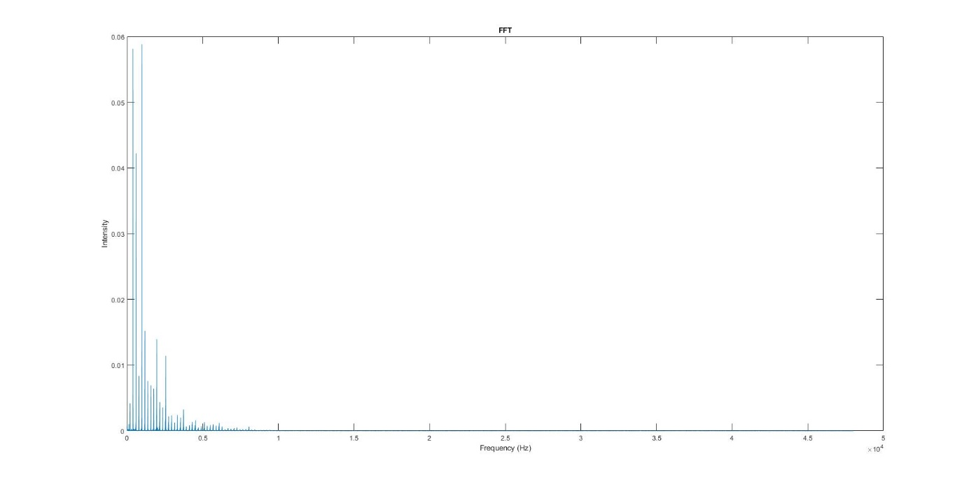
Figure 1: Kutz 100 Open G FFT
Note that the FFT will have a bandwidth of 48 kHz, meaning it is able to detect frequencies of up to 48 kHz. Most of the activity for all the open strings looks like this—the peaks are the harmonics of the fundamental. In this case, the fundamental frequency is the 196 Hz peak shown at the very left of the plot. While it may seem like the majority of the plot is zero or very close to it, zooming in and analyzing further shows that this is not the case. Due to the extreme differences in activity between the upper and lower frequency ranges, the two will have to be analyzed in different ways. Figure 2 shows a more enhanced version of the lower frequency range.
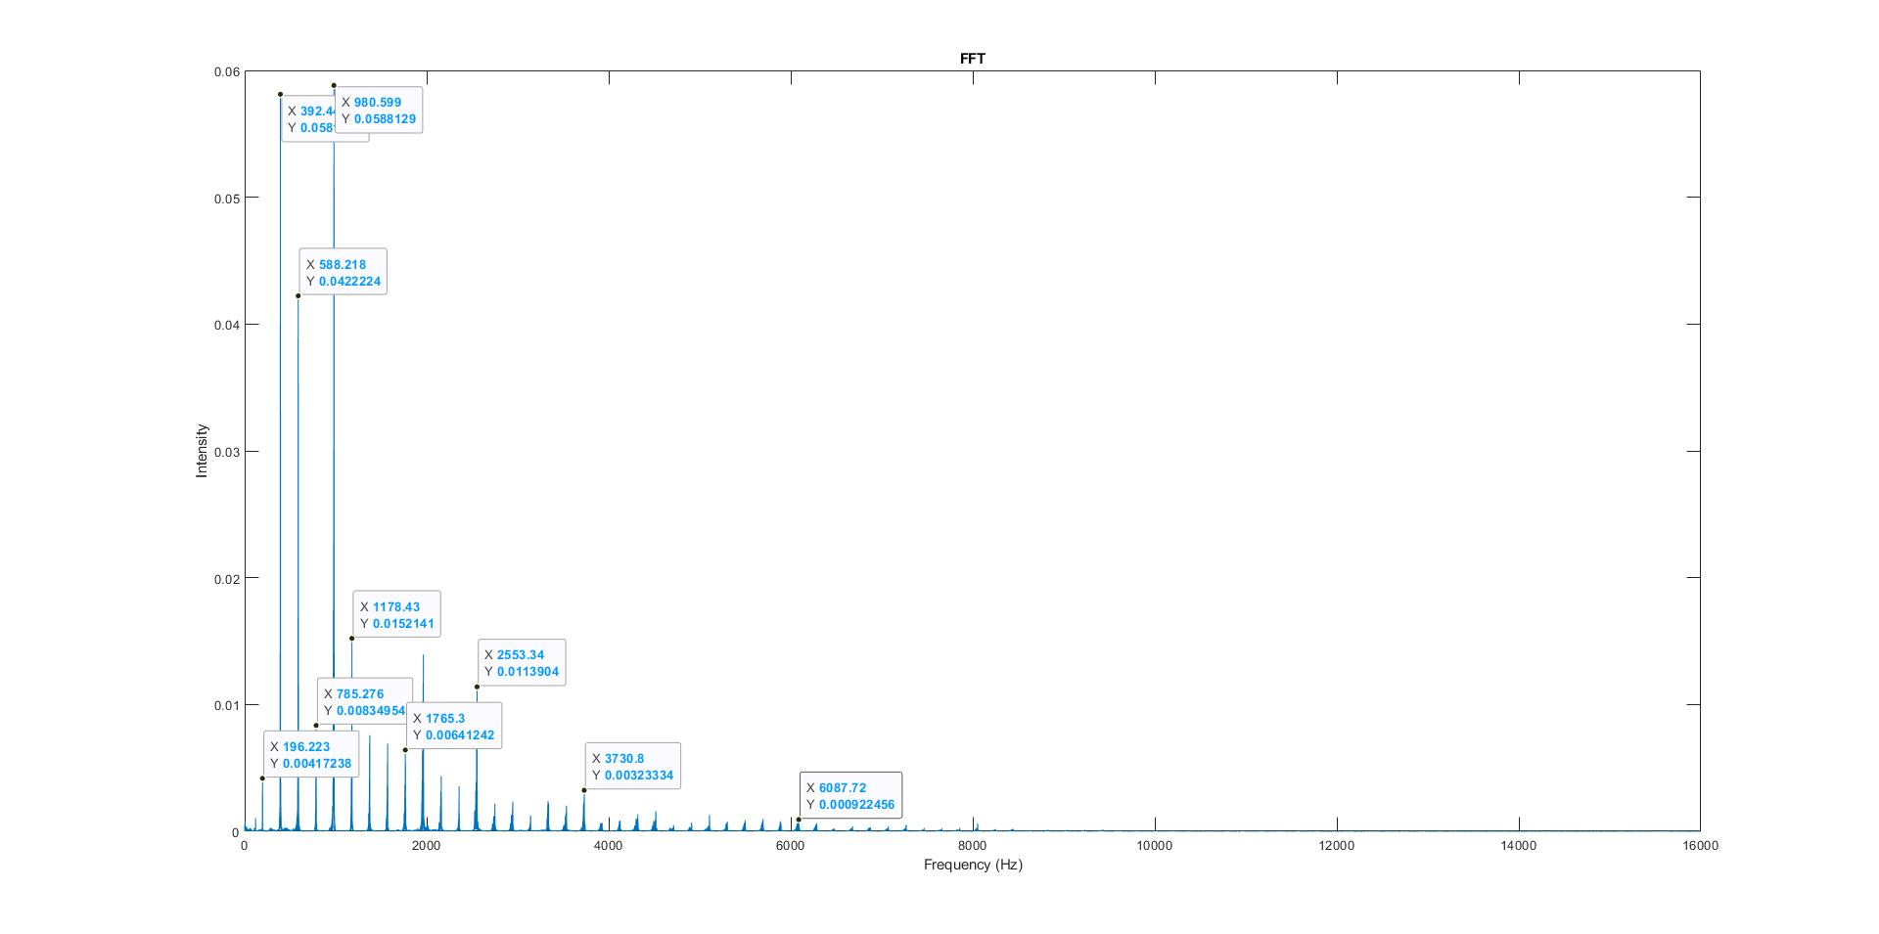
Figure 2: Kutz 100 Lower Frequency Range
Note that the peak of the fundamental on this instrument is very weak; in fact, this analysis tells us that the second, third, and fourth harmonics of the open G on the Kutz are at least 10 times stronger than the fundamental. Also note that the peaks on the harmonics of the lower frequency follow an approximately exponential trend, decreasing exponentially as frequency increases.
Let’s look at the upper frequency range; the magnitudes of the FFT in this range are much smaller than in the lower frequency range. This can be observed in Figure 3.
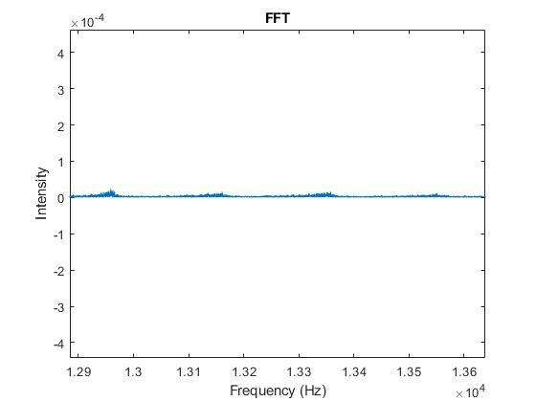
Figure 3: Kutz 100 Middle Frequency Range
The middle frequency range also exhibits some harmonics although significantly weaker. This trend also dies out around 20 kHz, which is commonly agreed upon as the limit of human hearing.
Spectrograms were also generated of the G major scale recordings, since the pitch varies with respect to time in the scale recordings. Both two dimensional and three-dimensional spectrograms were generated, each with their own drawbacks. The two-dimensional spectrogram can be seen in Figure 4. Due to the high sample rate, the spectrograms will also be need to split into three sections for analysis, as each section has different characteristics that need to be analyzed.
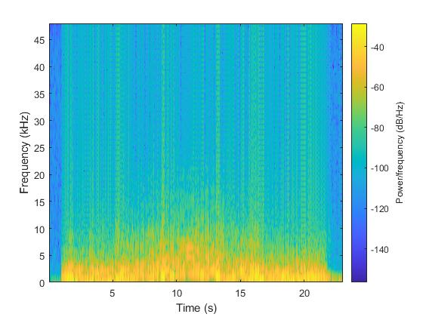
Figure 4: Kutz 100 G Scale Spectrogram
Most of the spectrogram also looks constant, since the spectrogram will also observe up to 48 kHz. The lighter color represents higher presence of harmonic. We can see steaks of harmonics going up the graph, showing that there is indeed upper harmonic behavior well beyond the human hearing range, enough to be detected by the algorithm.
Moving forward, the goal will be to extract the information contained within these higher frequency peaks. Once data processing is complete for all of the instruments, we will begin to compare instruments in the same price ranges to look for consistency and compare across price ranges to determine objective measures of differences in tone.

